Required Monthly Investment to Amass $1M - Corrected Full Answer
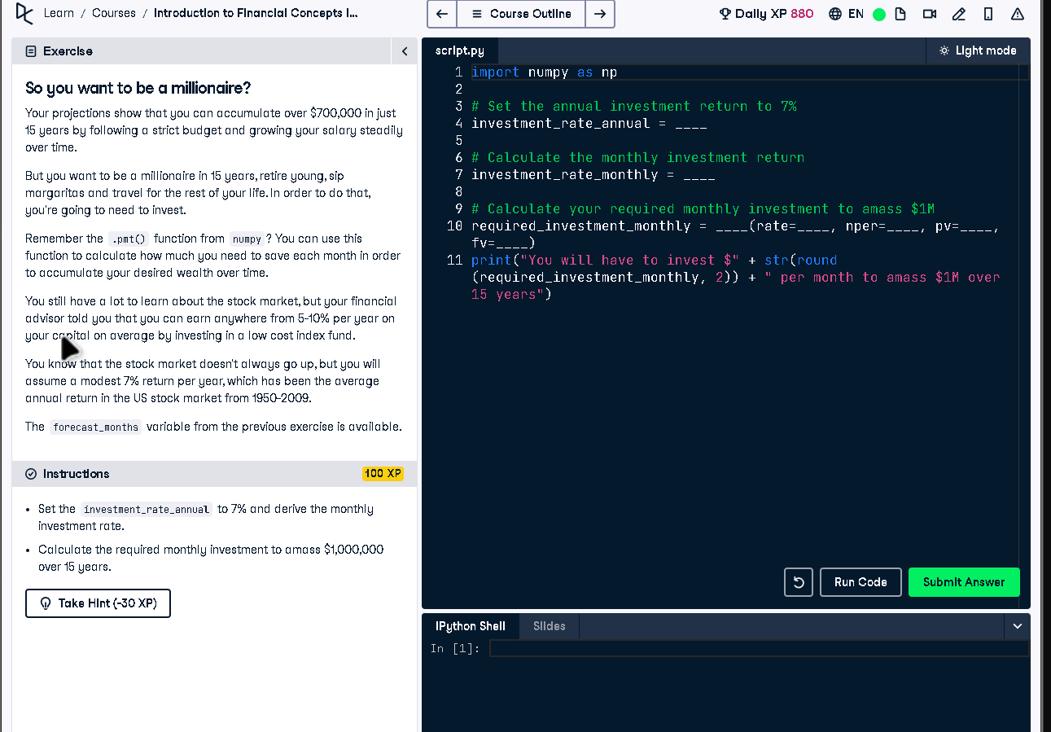

Full Code Answer:
import numpy as np
# Set the annual investment return to 7%
investment_rate_annual = 0.07
# Calculate the monthly investment return
investment_rate_monthly = (1 + investment_rate_annual)**(1/12) - 1
# Calculate your required monthly investment to amass $1M
required_investment_monthly = np.pmt(rate=investment_rate_monthly, nper=forecast_months, pv=0, fv=-1000000)
print("You will have to invest $" + str(round(required_investment_monthly, 2)) + " per month to amass $1M over 15 years")

Question:
How much monthly investment is needed at a 7% annual return to reach $1M in 15 years?

20-word Explanation (Question):
Monthly investment planning for $1M involves converting annual returns to monthly and applying payment formulas to determine contributions.

Answer:
Convert annual return to monthly compounding rate with (1 + annual)^(1/12) - 1, then calculate with np.pmt.

20-word Explanation (Answer):
By compounding annual return monthly and using np.pmt with the total periods, we compute required monthly investment precisely.

